**Systems Analysis and Design**

When creating a system, there are many methods that you could use to aid the life cycle of completing a project. All these methods work differently and are efficient in their ways for different types of systems. In this document, I will explain the life cycle and how these functions with each method.

The first method I will discuss is the Waterfall Method.

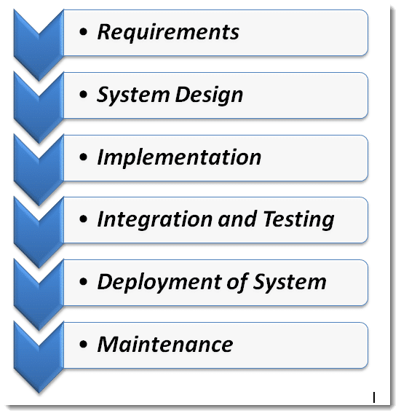**What is the Waterfall Method?**

The Waterfall Method focuses on a series of steps and is a point A to point b system. For each phase of development in this method, clear goals are set. The downside to using the waterfall model is that you cannot go back to a phase after completion. This is because it works like a waterfall and works one way.

**Development stages:**

1. Requirements - Request the information from the buyer that must be included in the system and store the information for a checklist.
2. System design – Create a plan/draft copy of how the end product should look with notes and relay feedback to the buyer to see if it is up to their standards.
3. Implementation – Once the buyer is happy with the draft copy from the system design stage, you can start to create the system more in-depth as a final product.
4. Testing – After you have finished creating the system and are ready to publish it for consumers to use you need to test every possible action to see if it is functioning as intended. If issues are discovered, discuss with the buyer’s workarounds to see if they are required functions with no possible way to fix them.
5. Publish – Once there are no issues with the system and the buyer is happy with the system, then you are ready to publish it for consumers to use.
6. Maintenance – After the system is online and consumers are using it, they may discover an issue that you overlooked, so you will need to listen to feedback from the consumer and fix issues accordingly to maintain interest and use.

**Iterative Model**

The iterative model is not the same as the waterfall model, as it is a recurring cycle after the planning phase is completed. A small set of tasks is repeated over it each time improving the current build.

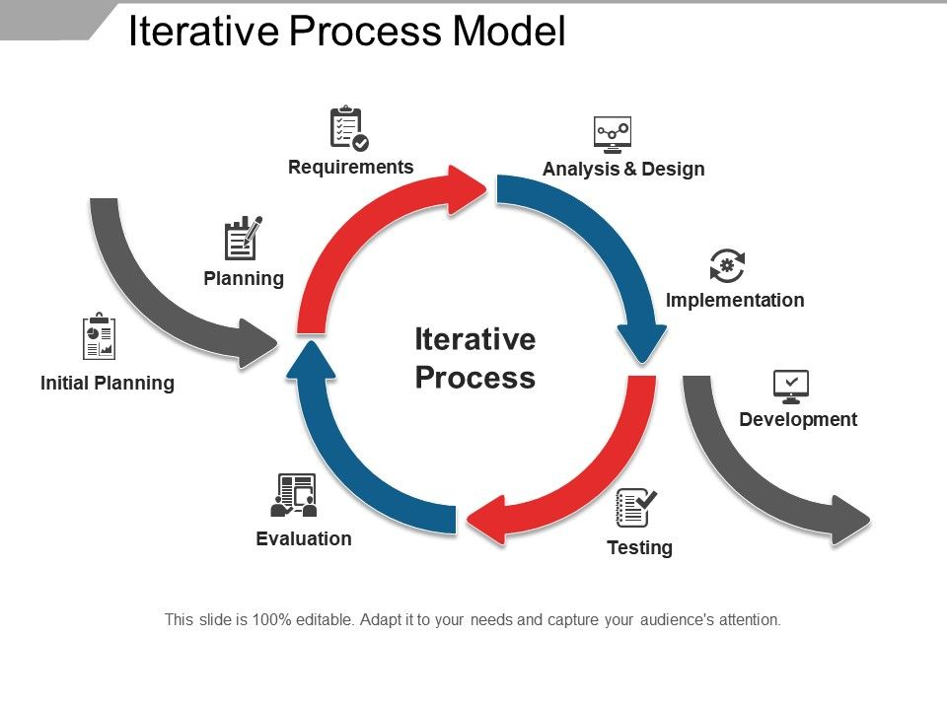**Development stages:**

1. Planning and requirements - The first step is to plan and generally prepare for the upcoming stages of the cycle by establishing software requirements and mapping out specific documents.
2. Analysis and design – An analysis should be performed once the planning is done. This is to figure out what database model to using and the appropriate business logic.
3. Implementation – Next all the design documents, planning and specification are implemented and coded into the final design of the project.
4. Testing – Now testing must take place to locate and identify any bugs or issues that have occurred.
5. Evaluation – Finally it is time to evaluate the project. This allows the project to be examined by everybody involved and see what changes need to be made and what still needs to be done to complete the project.

**Spiral Model**

The spiral model is a combination of both the Iterative model and the Waterfall model. Each stage starts with a design goal and ends with a review of the progress. Each development stage has a set of requirements that it must go through.

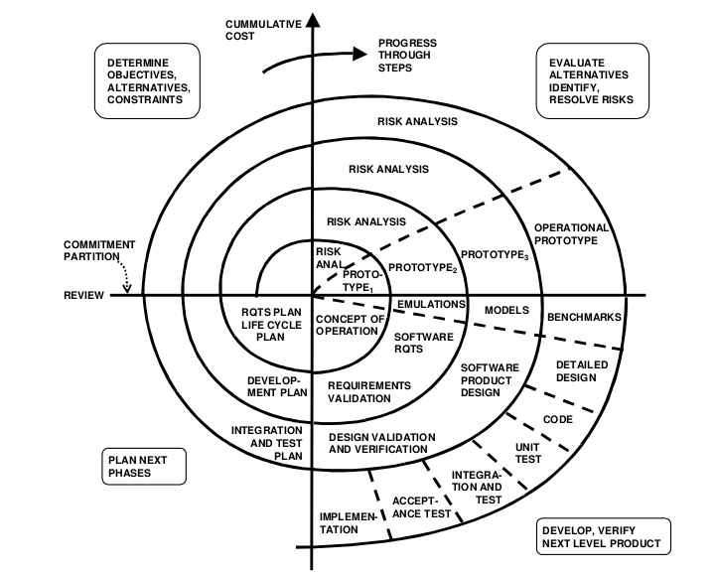

. **These development stages are:**

1. Planning – Estimating the cost of resources used or considering using
2. Risk analysis - Potential risks in the design
3. Engineering – Testing, coding, deploying
4. Evaluation – Identifying and monitoring software risks so far

**When to use the waterfall method**

* It can be ideal to use when the project is short
* The product stays the same throughout
* The project has no complicated requirements.
* When using a simple system

**When to use the Iterative Model**

* There are some goals and high risks that may change in the future
* Requirements are understood clearly and defined
* The development team are learning and using new technology that needs regular maintenance
* Skill sets needed for some resources and unavailable and are planned to be used on a contract basis
* It is used when there are a lot of ongoing changes throughout the life cycle
* When there are constant updates needed such as new items/offers

**When to use a Spiral Model**

* Cost and risk evaluation are important
* When it is a large project with a lot of requirements
* When the requirements are complex with lots of unclear goals

releases are required to be frequent

* high and medium risk projects as you can keep referring back to the life cycle checking if all is correct
* changes may be required at any time

I have chosen to use the Iterative model because I know that it will be suitable to use for a current build I am making as I will be able to update new items into the system add offers to items or remove them as it will be always updating as it is an ongoing system.

<https://xbsoftware.com/blog/software-development-life-cycle-spiral-model/> - spiral model diagram

<https://www.toolsqa.com/software-testing/waterfall-model/> - waterfall model diagram

<https://www.slideteam.net/iterative-process-model.html> - iterative model